
UNIVERSITY OF ENGINEERING AND TECHONOLOGY, PESHAWAR
JALOZAI CAMPUS

COURSE TITLE
Introduction To AI Programming
Open ended lab
SUBMITTED BY
Muhammad Saad
Reg no : 24JZELE0577
SUBMITTED TO
Sir Irasdullah
DEPARTMENT OF ELECTRICAL ENGINEERING
UNIVERSITY OF ENGINEERING AND TECHONOLOGY,
PESHAWAR, JALOZAI CAMPUS

Take the CityLearn dataset of the 2022 competition. Load the data of building_2 and perform the following.
- Load the dataset and store it in a list.
- Calculate the annual consumption.
- Calculate the monthly consumption.
- calculating daily consumption.
- Calculate the consumption of four seasons.
  - Winter: Dec–Feb
  - Spring: Mar–May
  - Summer: Jun–Aug
  - Autumn: Sep–Nov
- Calculate daily consumption over the weekdays for the whole year. Compare weekend vs weekday consumption.
- Visualize and interpret the data in a good-looking way.

TASK # 1

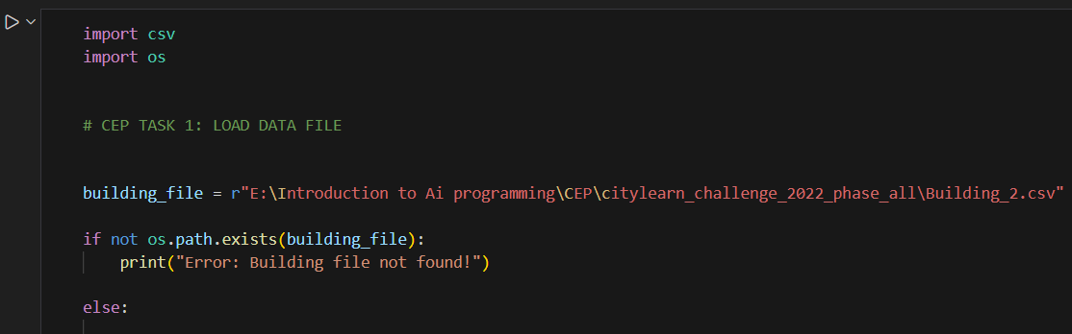

TASK # 2

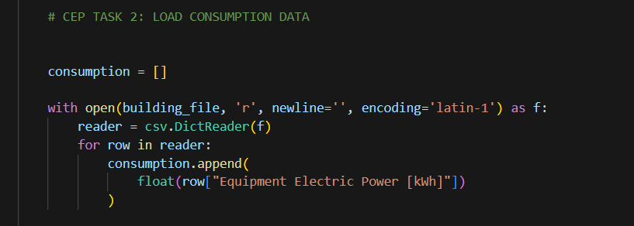

TASK # 3

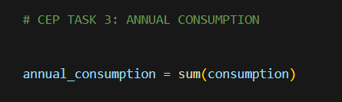

TASK # 4

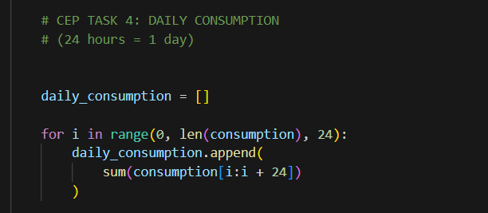

TASK # 5

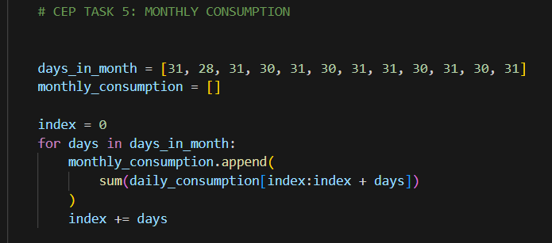

TASK # 6

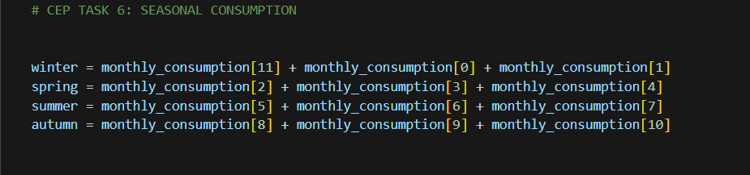

TASK # 7

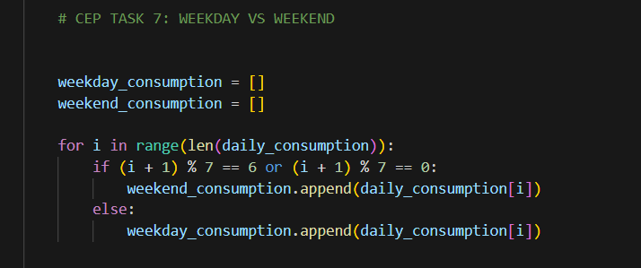

FINAL OUTPUT:

